I am interviewing candidates for Data Engineering roles with a focus on Python, SQL, ETL pipelines, and Data Modeling.
you're leading Data Engineering interviews! Here’s a structured way to start the interview, set the tone, and evaluate candidates effectively — especially for roles involving Python, SQL, ETL pipelines, and Data Modeling.
Kickoff: Set the Stage (2–3 min)
Start with a warm and clear introduction to put the candidate at ease:
Example Opening Script:
“Hi [Candidate Name], thanks for joining today. I’m Shailendra from Genpact ,and I’ll be leading your technical evaluation today for the Data Engineering role here at Genpact.
The focus will be on your experience with Python, SQL, ETL pipelines, and data modeling — things we work with daily. The goal is to understand how you approach real-world data engineering problems. Feel free to ask questions at any point — we want this to be interactive."
"Let’s start with a quick overview of your background and recent projects — especially any work that relates to data engineering."
Ready to jump in?”

✅ 2. Candidate Introduction (3–5 min)
Let them talk first. It gives you:
- Context on their experience
- Time to plan follow-ups
Ask:
“Can you give me a quick overview of your experience, especially around data engineering tools and projects you’ve worked on recently?”

✅ 3. Technical Deep-Dive (25–35 min)
Here’s how you might break it down:
🔸 A. Python (5–10 min)
- Ask a problem-solving or scripting question
- Assess logic, error handling, and coding style
Example:
“How would you write a Python script to process a 5GB CSV and load valid records into a database, while logging errors?”
Or:
“Can you show how you'd remove duplicates from a list of dictionaries?”

🔸 B. SQL (5–10 min)
Give a real-world scenario or table and ask a query:
Example:
"Given a transactions table, can you write a query to get the top 3 customers by spend in the last 30 days?"
Or:
"How would you detect duplicate rows in a table with no primary key?"

🔸 C. ETL & Pipelines (5–10 min)
Ask about designing or troubleshooting pipelines.
Example:
“Let’s say you get daily JSON data from an API, but sometimes the schema changes. How would you build a pipeline to handle that?”
Or:
“What strategies would you use to make ETL jobs idempotent and fault-tolerant?”

🔸 D. Data Modeling (5–10 min)
Pose a scenario and ask how they’d model it.
Example:
“You’re building a model for a subscription-based app (users, plans, renewals). How would you design the dimension and fact tables?”
Or:
“Can you explain how you’d implement SCD Type 2 in a data warehouse?”

✅ 4. Behavioral / Collaboration (5–10 min)
Gauge how they work with teams and handle issues.
Example:
“Tell me about a time a data pipeline failed in production. How did you fix it and prevent future failures?”
Or:
“How do you prioritize between data quality and delivery deadlines?”

✅ 5. Wrap Up & Questions (5 min)
Give them time to ask questions and close smoothly.
You Can Ask:
“Is there anything you’d like to ask me about the role, the team, or the tech stack?”
Then wrap with:
“Thanks for your time — great talking to you. We’ll be in touch with the next steps soon.”

___________________________________________________________________

scenario-based technical questions you can ask candidates during a Data Engineering interview, tailored to evaluate their real-world problem-solving skills across Python, SQL, ETL pipelines, and Data Modeling. These go beyond theory and are great for assessing practical expertise.
- Data Lake vs Data Warehouse Design
Scenario: You’re starting from scratch. The business wants both exploratory data analysis and structured reporting.
Questions:
- How would you design the architecture using a data lake + data warehouse?
- What layers would you include in your data lake (raw, cleaned, curated)?
What are tradeoffs between storing data in Parquet on S3 vs Redshift/Snowflake?

Slowly Changing Dimensions (SCD) and Change Data Capture (CDC) are both techniques for handling data changes over time, but they solve different problems in the data pipeline or data warehouse architecture.
SCD is a data warehousing concept used to track historical changes in dimension attributes (e.g., customer name, address, job title) in a dimensional model (star/snowflake schema).
CDC is a data ingestion technique that identifies and captures changes in source systems (DBs) — inserts, updates, deletes — so you can replicate or stream them into downstream systems (like data lakes, warehouses).
Final Thoughts
- CDC = How you get changes from source
- SCD = How you store and model those changes in your warehouse
You use CDC to keep a data warehouse in sync with an OLTP source system, minimizing latency and load.
• You might use CDC to detect a change in a customer record, then
• Apply SCD logic in your warehouse to update the dimension table properly.
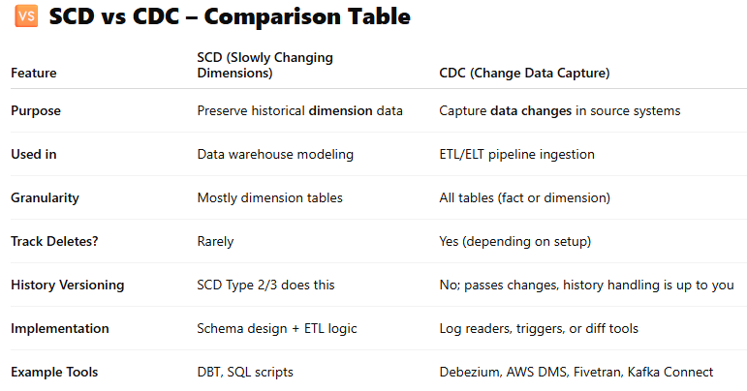

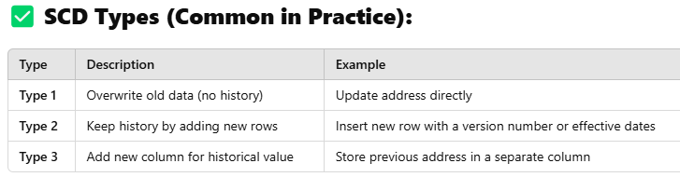
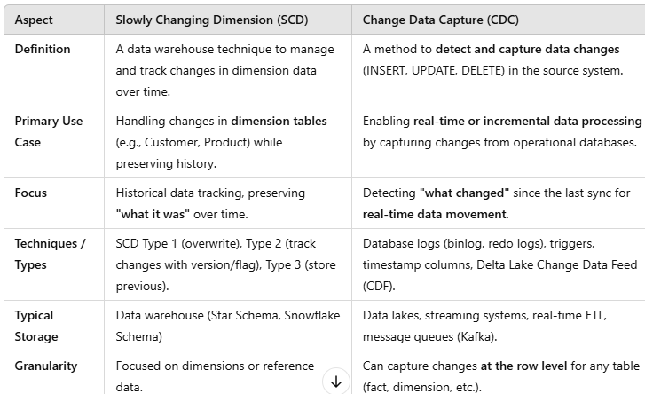

1. ETL Pipeline Scenario
Scenario: You're working with a daily transaction feed (CSV) from a payment processor. Occasionally, the file has corrupt rows or missing fields. You need to ingest this into a data warehouse.
Questions:
- How would you design an ETL pipeline to handle this?
- How would you detect and handle corrupt/malformed rows?
- How will you ensure idempotency in case of a rerun?
- How would you monitor the pipeline and alert failures?

🔸 2. SQL Performance Tuning
Scenario: A dashboard is powered by a SQL query that’s suddenly running very slow after data volume increased.
Questions:
- What steps would you take to diagnose the root cause?
- How would you optimize a query scanning 100M+ rows?
- How would indexes, partitioning, or denormalization help here?
- What are your thoughts on materialized views in such a scenario?

🔸 3. Data Modeling for a New Feature
Scenario: Your company is launching a new "Subscription" feature for users. You need to extend the data model.
Questions:
- How would you design the data model for subscriptions, including status changes (active, paused, canceled)?
- How would you handle historical tracking?
- How would your model support daily active user metrics and revenue reporting?

🔸 4. Late-Arriving & Out-of-Order Data
Scenario: You’re processing clickstream events from Kafka. Sometimes events arrive hours late or out of order.
Questions:
- How would you handle late-arriving data in your pipeline?
- How would you aggregate real-time metrics (like daily active users) correctly?
- What tools or frameworks would you use for event time windowing?

🔸 5. Data Quality & Validation
Scenario: You’ve been asked to onboard a new source system (CRM data). It’s known to have inconsistent and dirty data.
Questions:
- What data validation checks would you apply during ingestion?
- How would you track data quality metrics like null rates, schema drift, duplicates?
- Have you used tools like Great Expectations or dbt tests?

🔸 6. Python Automation / Scripting
Scenario: You receive Excel reports daily via email, and need to ingest them into a warehouse.
Questions:
- How would you automate the ingestion pipeline in Python?
- How do you handle different Excel formats, missing columns, or corrupt files?
- How would you log and retry failed loads?

🔸 7. Incremental Loading
Scenario: You’re asked to build a pipeline for a PostgreSQL table with 10 million records. Only 2–3% change daily.
Questions:
- How would you implement incremental loading?
- How would you track changes without a reliable updated_at column?
- What are different ways to implement Change Data Capture (CDC)?

🔸 8. Schema Evolution
Scenario: A JSON data source is known to change its schema frequently (adding/removing fields).
Questions:
- How do you design your ingestion to be resilient to schema changes?
- How would you track versioning of schema?
- What challenges could arise in parquet or delta formats, and how would you handle them?

🔸 10. Real-World Debugging
Scenario: A pipeline that has worked for months suddenly fails with a “null pointer exception” in production. The last code change was weeks ago.
Questions:
- How would you approach debugging and identifying the root cause?
- What logging and alerting would you expect to be in place?
- How would you design pipelines to be self-healing or auto-retry?

✅ Bonus: Behavioral Tie-ins
You can finish each scenario with:
- “Have you faced anything similar in your past projects?”
- “What trade-offs did you make, and why?”

Here's a set of targeted technical questions for Data Engineering interviews, categorized by skill area: Python, SQL, ETL pipelines, and Data Modeling. These questions help assess both foundational understanding and real-world implementation skills.
PYTHON (Data Engineering Context)
1. File Handling & Large Data
- How would you process a large CSV file (>10GB) without running into memory issues?
- What is a generator? How is it useful in ETL jobs?
2. Error Handling
- How do you handle retries and logging in Python ETL scripts?
- Can you explain the use of try-except-finally with an example?
3. Pandas / PySpark Use
- When would you prefer pandas over PySpark, and vice versa?
- How do you handle missing or corrupt records in a DataFrame?
4. Serialization & APIs
- How do you parse and validate nested JSON data in Python?
- How would you write code to consume paginated API data and push it to a database?

🔹 SQL
1. Joins & Aggregations
- What’s the difference between INNER JOIN, LEFT JOIN, and FULL OUTER JOIN?
- Write a SQL query to get the second-highest salary from an employee table.
2. Window Functions
- Explain how ROW_NUMBER() works. When would you use it?
- Use a window function to calculate a 7-day moving average.
3. Optimization & Indexing
- How would you improve the performance of a slow SQL query?
- What’s the difference between clustered and non-clustered indexes?
4. Data Validation
- Write a SQL query to detect duplicate rows in a table with millions of records.

🔹 ETL PIPELINES
1. Pipeline Design
- Describe how you would build a pipeline to ingest daily sales data from a REST API into a data warehouse.
- How do you ensure your ETL pipelines are idempotent?
2. Incremental vs Full Loads
- How would you implement an incremental load from a source table that doesn’t have an updated_at field?
3. Tools & Orchestration
- What tools have you used for scheduling and orchestration (e.g., Airflow, Prefect, Luigi)?
- How do you manage dependencies and retries in Airflow?
4. Logging & Monitoring
- How do you design pipelines to provide observability (logging, metrics, alerts)?
- What monitoring tools have you used in production pipelines?

🔹 DATA MODELING
1. Star vs Snowflake Schema
- Explain the difference between a star schema and a snowflake schema. Which do you prefer and why?
2. Slowly Changing Dimensions
- How do you handle Slowly Changing Dimensions (SCD Type 2) in your data model?
3. Fact vs Dimension Tables
- What is the difference between a fact table and a dimension table? Give examples.
4. Normalization/Denormalization
- In what cases would you choose to denormalize your data model?
5. Real-Time Use Case
- If a business wants to track a user’s real-time session behavior across multiple pages, how would you model that?

✅ BONUS: CROSS-CUTTING/SCENARIO QUESTIONS
- Describe a time when a pipeline failed in production. How did you debug it?
- What strategies do you use to ensure data quality and consistency?
- How do you handle schema evolution (e.g., JSON structure changing over time)?

